

**Mobile Application Development**

**Semester Project Report**

**Project Title: Venue Vibes**

**Group members:**

**Noor Fatima (21sw062)**

**Diya Kumari (21sw032)**

**Submitted to:**

**Ma’am Mariam Memon**

**Expected Deliverables: Requirements for report submission**

1. Project Proposal (Deadline: 22 September 2024) 🡪 Already Done

2. Working Application (GitHub Links) (Deadline: 25 October 2024) 🡪 GitHub link (<https://github.com/Noor-Fatima-Ansari/Venue_Vibes> )

3. A report with following sections: (Deadline: 25 October 2024) 🡪 All the required sections are discussed below.

• **Real World Problem Identification**

Event organization has become increasingly popular and essential in today's fast-paced world.

Planning an event, whether it’s a business meeting, birthday celebration, graduation party, or family gathering, often involves a lot of guesswork, especially when it comes to budgeting and selecting the right activities. This can be a significant challenge and source of stress for organizers.

**• Proposed Solution**

To address the challenges of planning and managing events efficiently, we've developed a technical software solution that simplifies the entire process.

. Our system eliminates this hassle by providing a streamlined and efficient solution, making event organization easier and more manageable. With our software, you can plan and execute your event with confidence, knowing that all aspects are covered efficiently.

1. **Food Estimation:** Accurately estimate the quantity of food required based on the number of attendees, ensuring no wastage or shortage.
2. **Activity Suggestions:** Recommend engaging and age-appropriate activities for attendees, tailored to their age groups, ensuring a memorable experience.
3. **Venue Decoration:** Assist in decorating the event space in an extraordinary manner, helping to create the perfect ambiance for any occasion.

**Technical implementation:**

These are the following screens in our project:

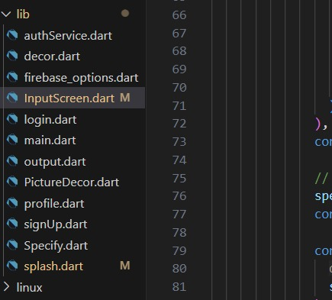

**Login Screen:** As the app is opened first page is of login screen, where email and password is required and these credentials will be verified through firebase authentication.

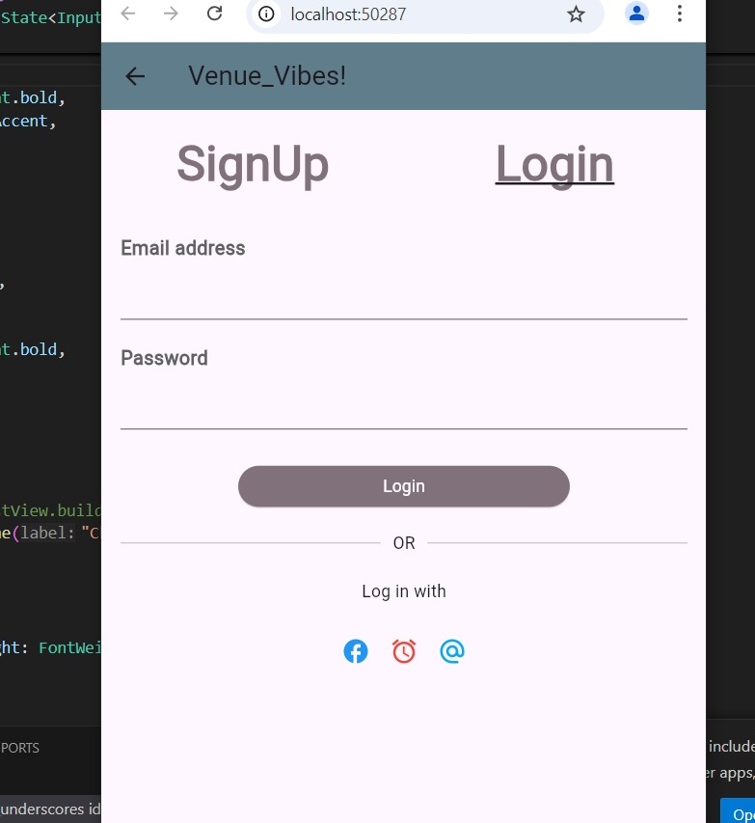

**PictureDecor:** As user login credentials are verified then user will see the following screen where he/she can select the venue and the type of event he want to organize, he may select from the given list of venues or may upload the picture of the venue that he wants to customize according to event type, For now we have not added functionality, It is just UI of the particular screen.

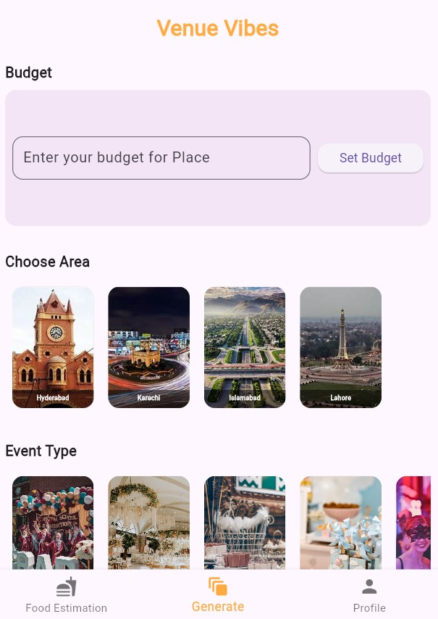 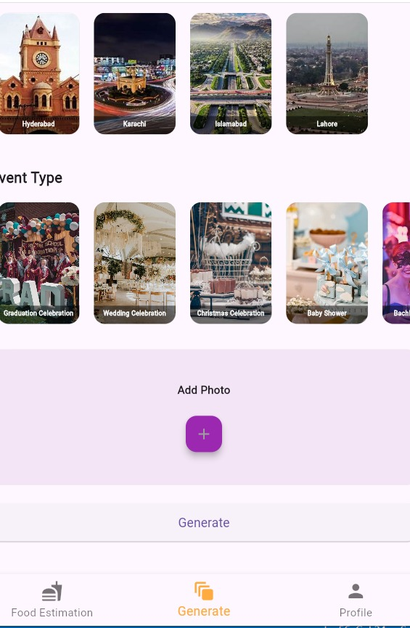

hgf

**Input screen:** After clicking generate on the above screen user will come to the following screen, where he will specify budget for the food and the number of people (will join the event) including no of males, females and kids. This data will be stored on the firestore cloud, from where we can fetch the data whenever we want.

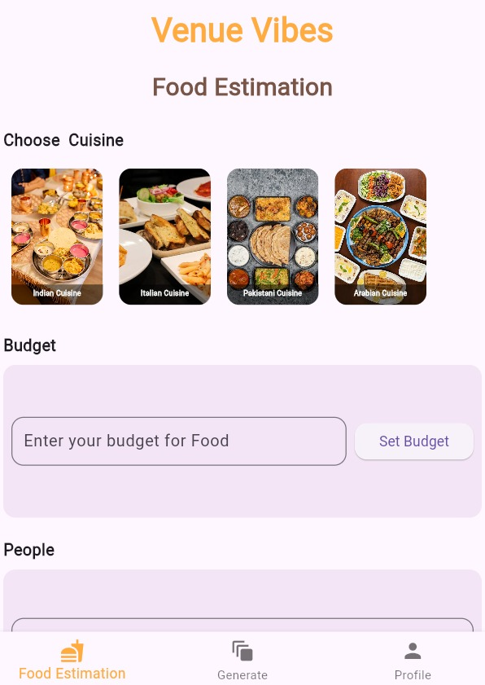 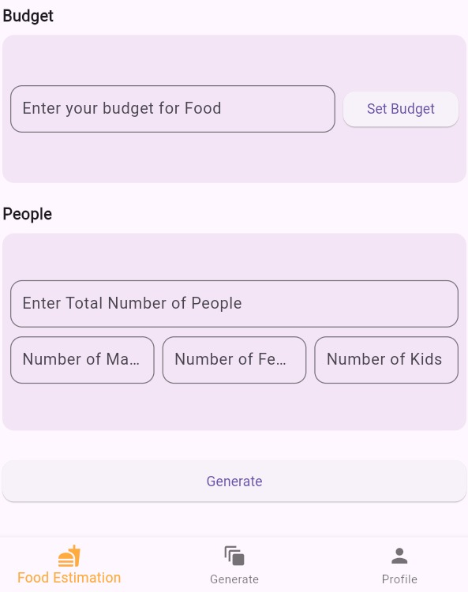

**Output screen:** After clicking generate on the above screen user will come to the following output screen, where for now demy data is show, otherwise it needs to be updated according to the user input.

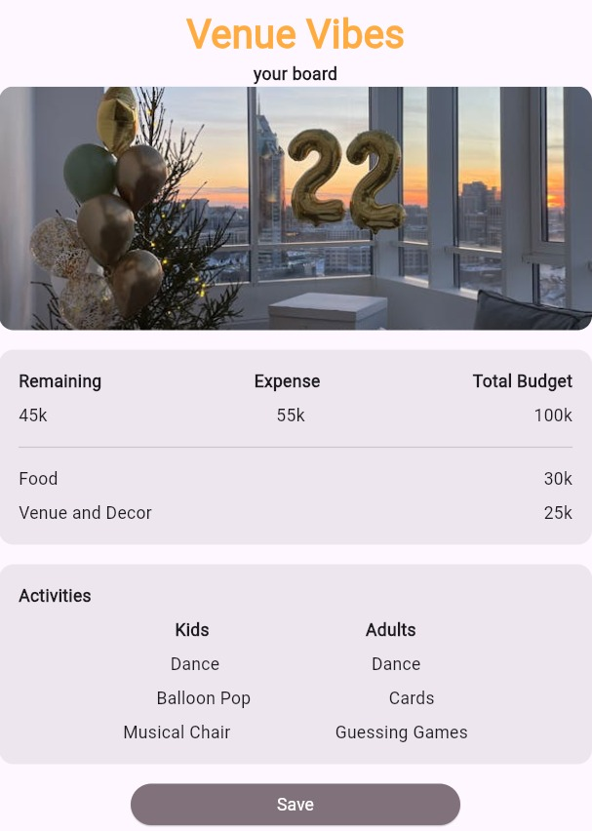

**Profile screen:** On the profile, it shows all the previous data of the event that the particular user had organized by putting all the necessary information, it shows venue name, your budget and the information icon in the right bottom, on pressing it will show other data stored on the cloud, which is shown on the next picture.

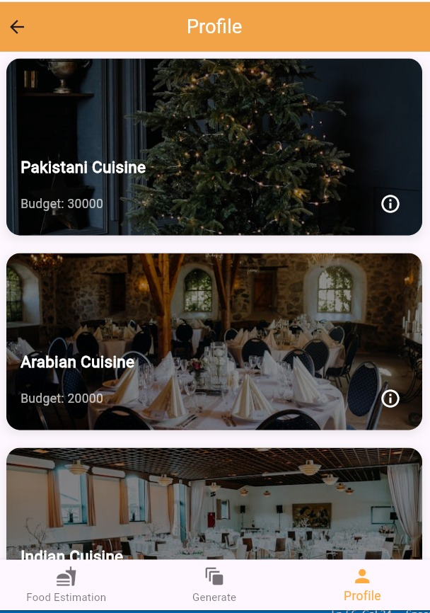 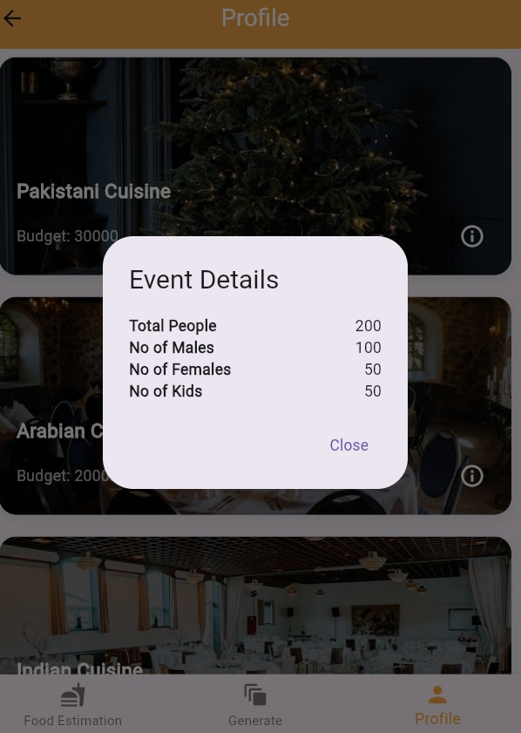

**• Responsive User Interfaces (Screenshots of your app on different screens & platforms)**

**Used the media query to achieve the responsiveness**

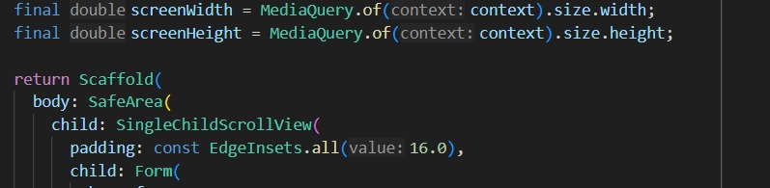

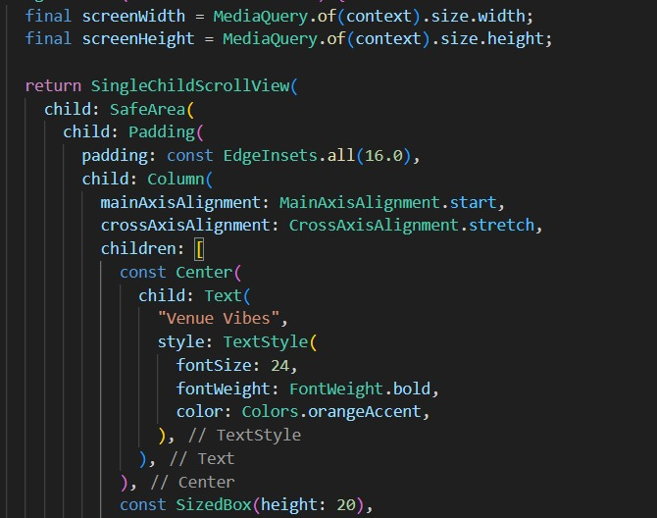

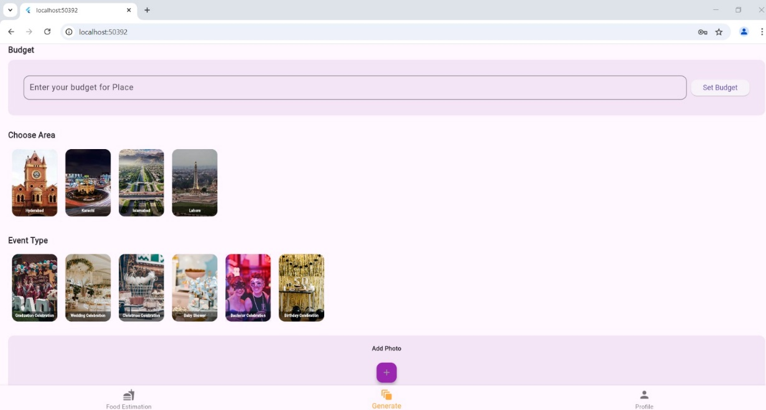

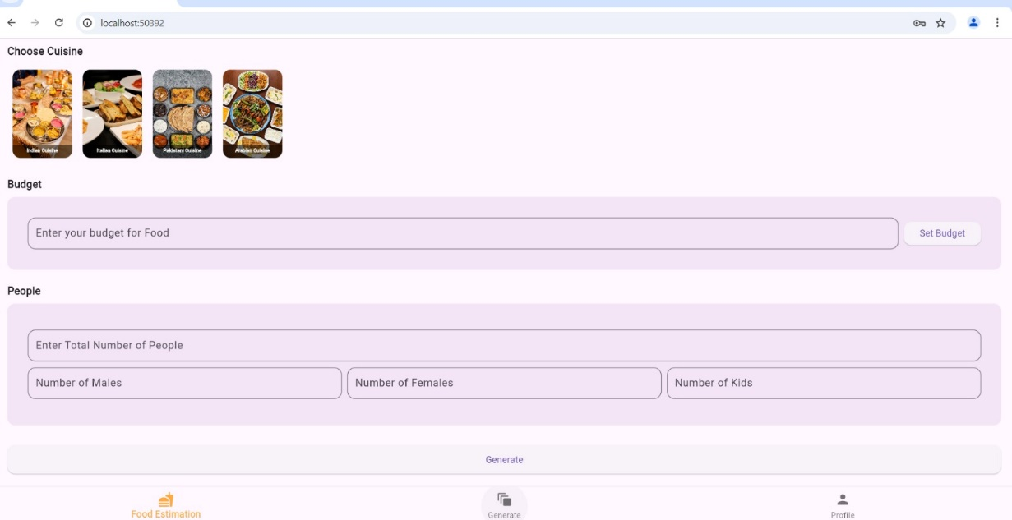

**•** **Data Storage (With justification for using a particular database)**

**Authentication:**

In our event decor app, Firebase Authentication enables secure user login, allowing users to access their personalized event data, including budgets, attendees lists, and decoration preferences, across multiple devices. By supporting the login methods (like email and password), it ensures a smooth onboarding experience. Moreover, Firebase Authentication integrates with Firestore, ensuring that each user's event details and decor history remain private and accessible only to them.

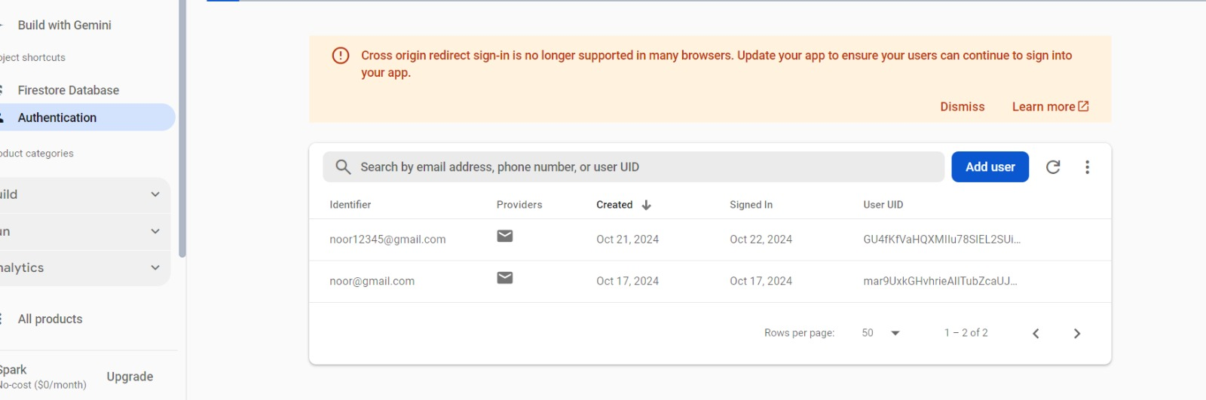

**Data storage:**

The primary reason for storing data in the cloud using Firestore is to provide secure, scalable, and real-time access to event details such as budgets, attendee counts, and decoration preferences. Users can log in to their accounts from any device and view all their event history on the profile page. Firestore's user-restricted access ensures that each user's data remains private and protected while enabling easy updates and retrieval of event plans. However, the app doesn't currently allow editing decoration suggestions stored in the cloud to maintain consistency and integrity of pre-defined options.

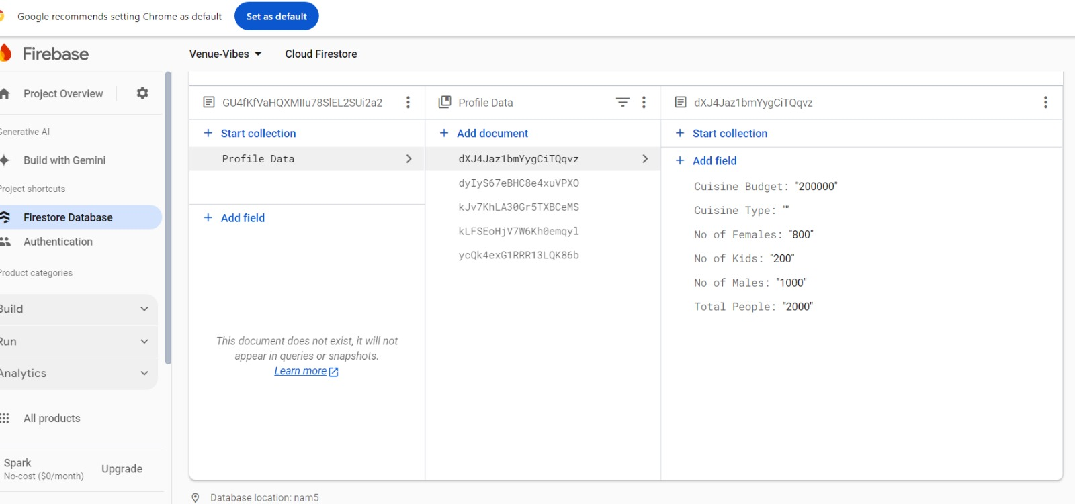

• **Issues and Bugs Encountered and Resolved during Development:**

**Error no: 1**

Issue in navigating the pages in bottom navigator.

Solution: To fix it we passed the required function inside the constructor of classes that maintain the track of current index of bottom navigator.

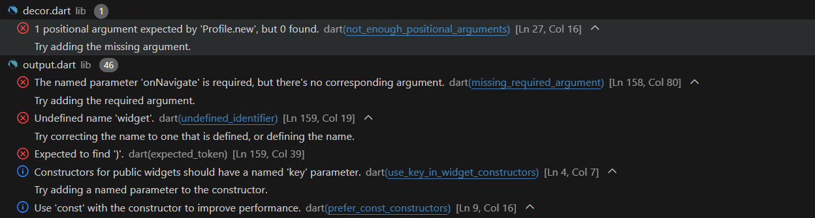

**Error no: 2**

Issue faced during connection of firebase in the project, this might happened because of poor internet connection.

Solution: This issue was sorted by solving the issue of CLI, and the CLI issue was solved by running the following command.

firebase-tools-instant-win

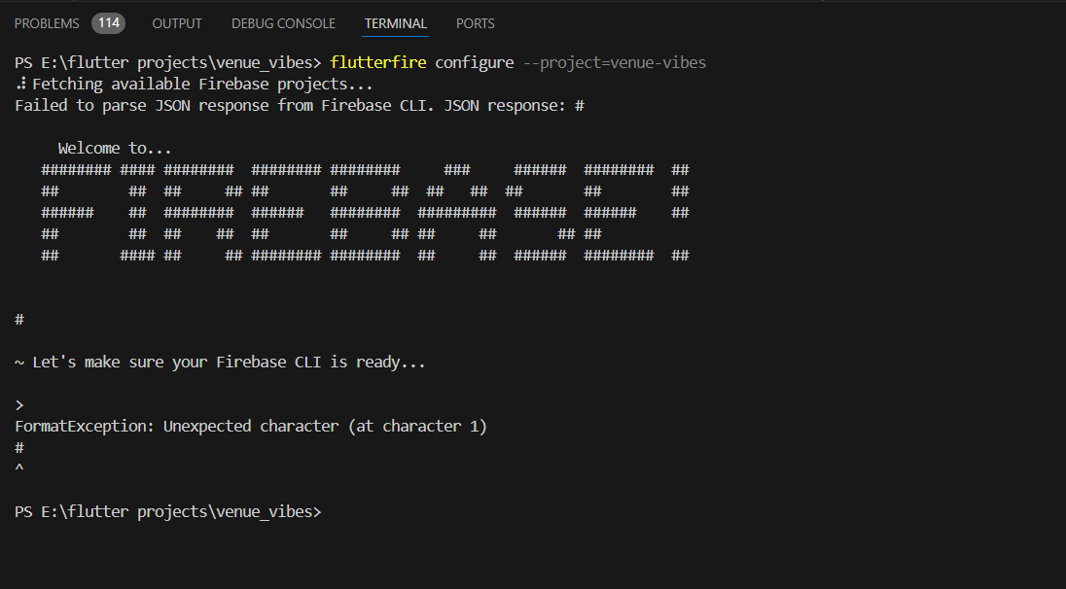

**Error no: 3**

Firestore connection issue.

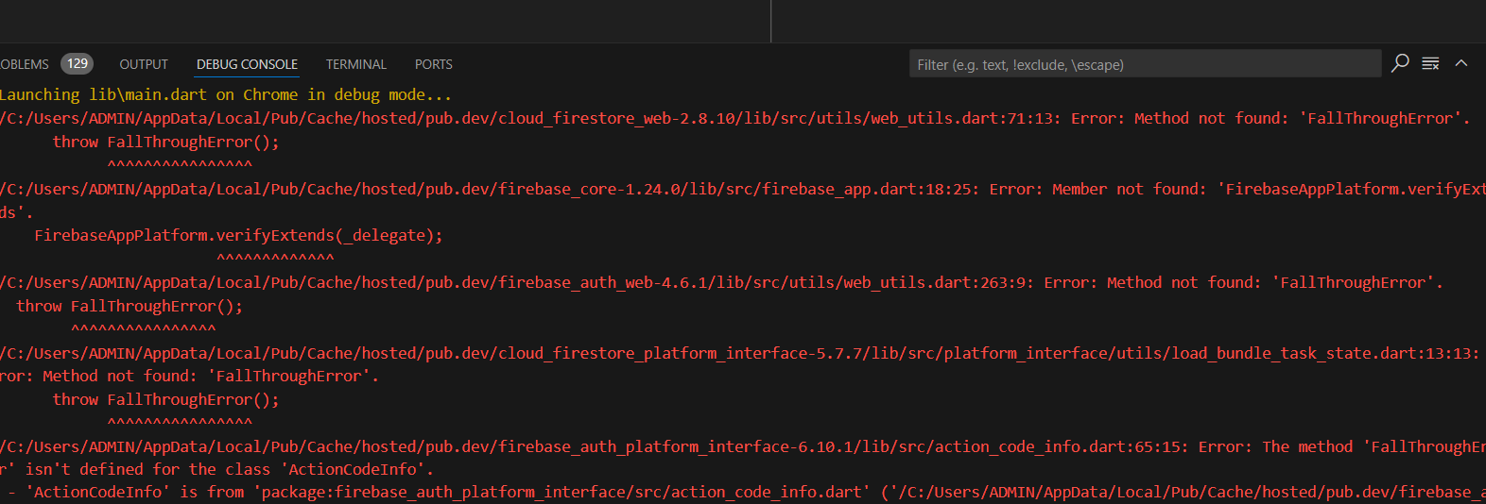

**Error no: 4**

Firebase configuration error.

